EXPERIMENT 6

Name: Arav Desai | Roll No: 3
Subject: DE | Class/Batch: AIML A/ B-1
Date of Performance: | Date of Submission:

Theory
Multiplexer (MUX)
A multiplexer is a combinational logic circuit that selects one input line from several input signals and forwards it to a single output line. It's often referred to as a "data selector." Multiplexers are widely used in communication systems, data routing, and signal processing.

Working Principle:
- Inputs and Selection Lines: A multiplexer has multiple data inputs, a single output, and selection lines. The number of selection lines (n) determines how many input lines (2ⁿ) the multiplexer can handle.
- Selection Process: The state of the selection lines determines which input is connected to the output. For example, in a 4-to-1 MUX, there are 4 inputs, 2 selection lines, and 1 output.

Truth Table Example (for 4-to-1 MUX):
S0 | S1 | Y
0 | 0 | I0
0 | 1 | I1
1 | 0 | I2
1 | 1 | I3

Here, I0, I1, I2, and I3 are the input signals, and S1 and S0 are selection lines.
Applications:
- Data transmission in communication systems.
- Switching circuits in telecommunication networks.
- Display systems.

De-Multiplexer (DEMUX)
A de-multiplexer, or DEMUX, is essentially the opposite of a multiplexer. It takes a single input signal and distributes it to one of the many output lines based on the selection line values. It's often referred to as a "data distributor."

Working Principle:
- Inputs and Outputs: A de-multiplexer has one data input, multiple output lines, and selection lines.
- Distribution Process: The state of the selection lines determines which output line will receive the input signal. For example, in a 1-to-4 DEMUX, there is 1 input, 2 selection lines, and 4 outputs.

Truth Table Example (for 1-to-4 DEMUX):

S0 | S1 | Y
0 | 0 | O0
0 | 1 | O1
1 | 0 | O2
1 | 1 | O3

Here, O0, O1, O2, and O3 are the output lines, and S1 and S0 are selection lines.

Applications:
- Data distribution in communication systems.
- Decoding information in computer systems.
- Signal routing in electronic systems.

Key Difference Between MUX and DEMUX:
- Multiplexer: Multiple inputs, single output.
- De-Multiplexer: Single input, multiple outputs.
- MUX performs data selection, while DEMUX performs data distribution.

Circuit

Multiplexer Circuit:
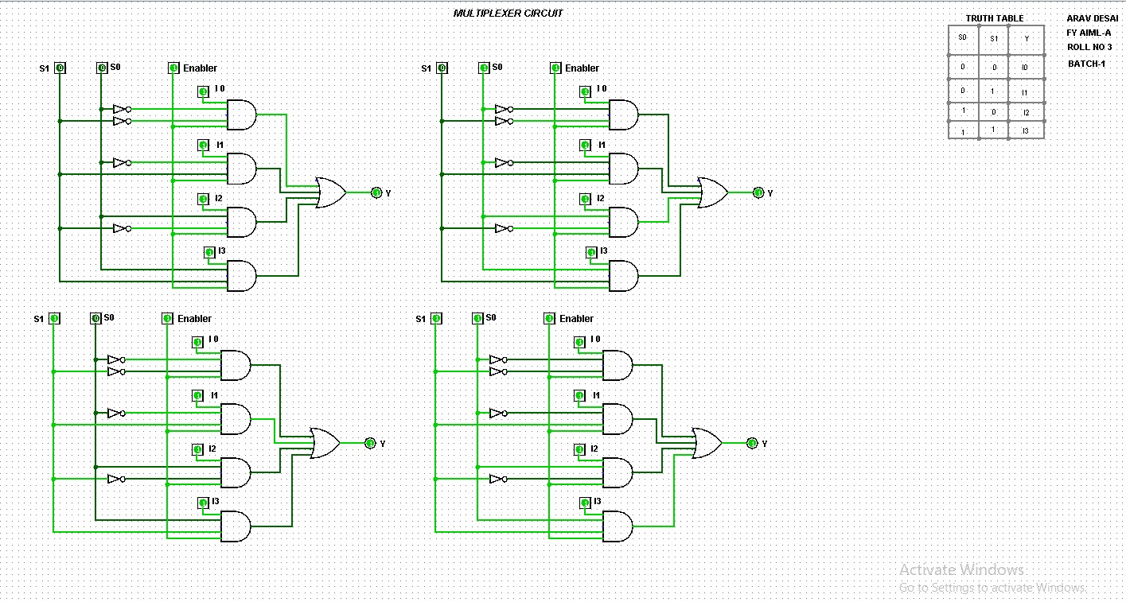

De-Multiplexer Circuit:
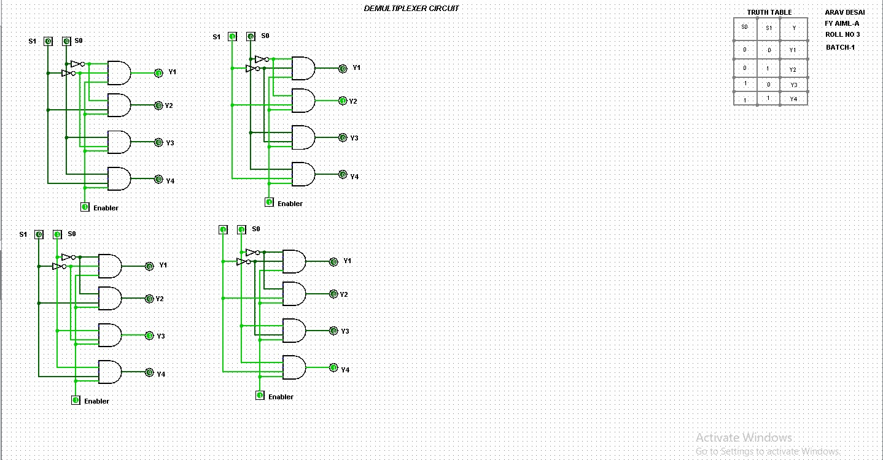

Conclusion
In conclusion, multiplexers and de-multiplexers are essential devices in digital electronics and communication systems, having opposite functionalities, to facilitate effective data transmission management. Demultiplexers distribute a single input signal among multiple outputs based on selection criteria, in contrast to multiplexers, which select and forward the desired input signals to a single output.
Assessment

Timely Submission  (7) | Presentation  (06) | Understanding  (12) | Total  (25) | Sign

